AGILE SPRINT PLANNING AND USER STORY WORKSHOP
AI-Powered Smart Aquifer Monitoring and Groundwater Conservation Platform
Sprint Planning Document
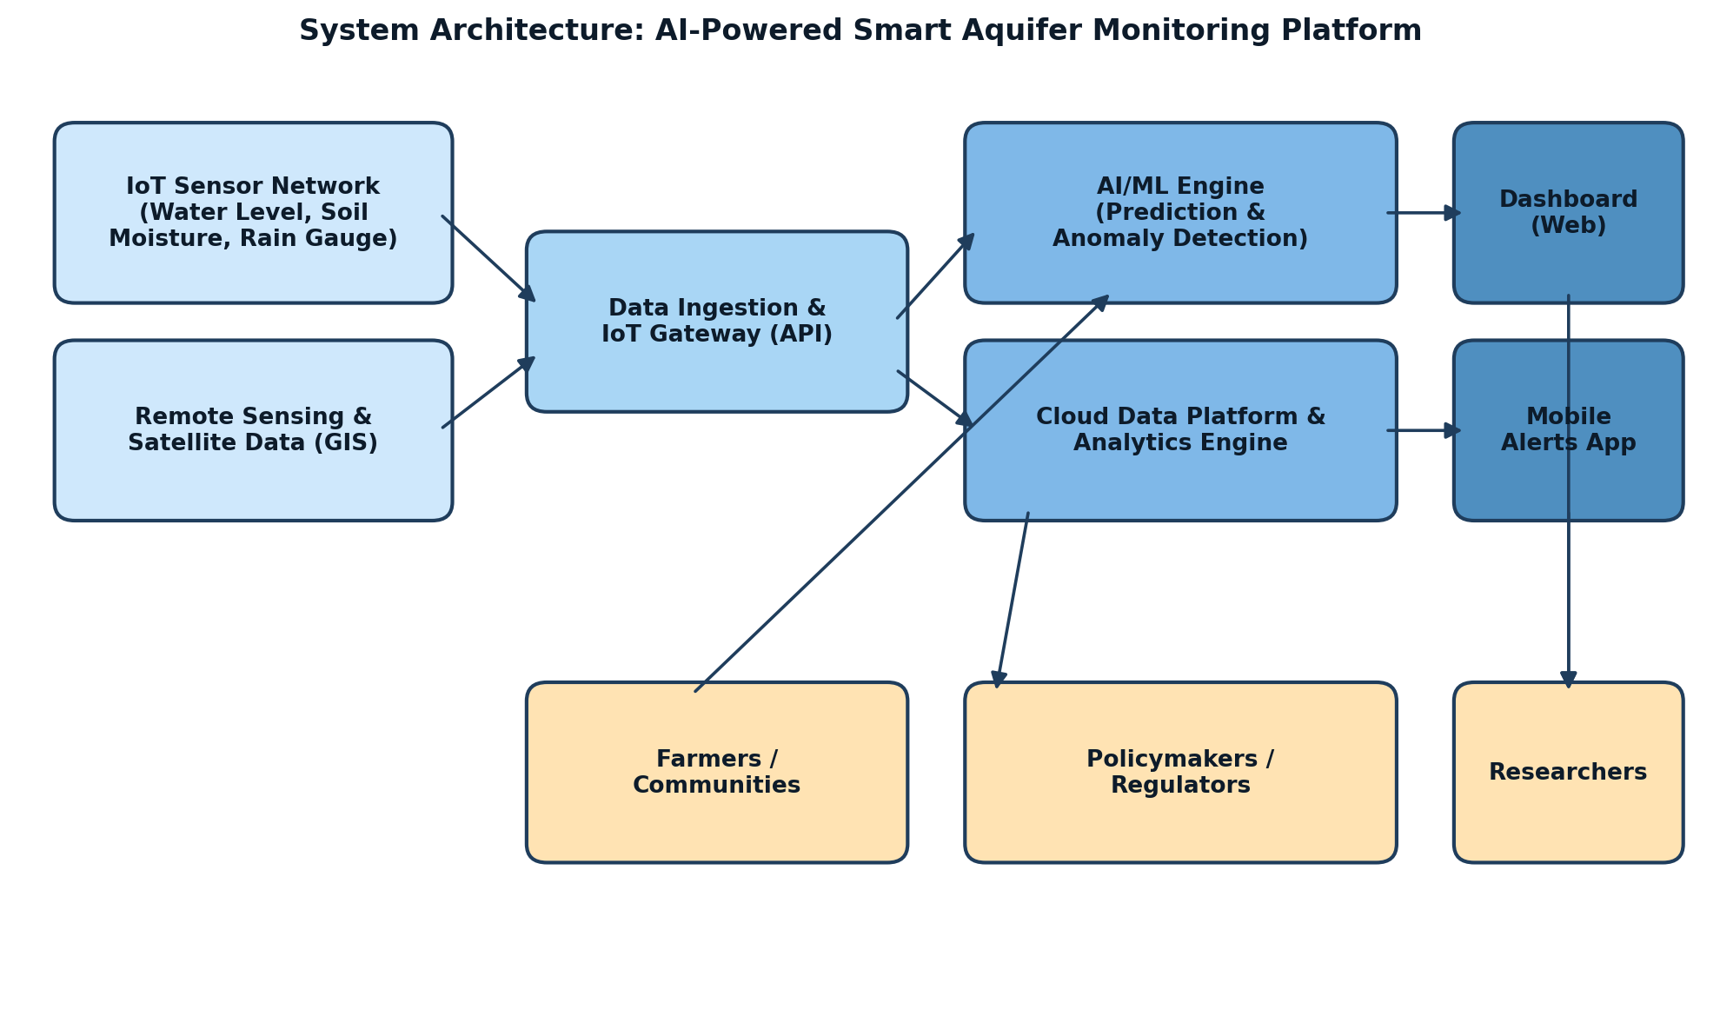

Submitted By | Y. Rishitha Reddy
Register No. | 192424233
Department | Artificial Intelligence and Data Science
Subject | Software Engineering
Faculty | Dr. Latha R.
College | SIMATS Engineering
Academic Year | 2024 – 2028

1. Project Vision and Stakeholders

1.1 Project Vision
To build an AI-powered Smart Aquifer Monitoring and Groundwater Conservation Platform that unifies IoT sensor networks, remote-sensing/GIS data, and machine-learning analytics into a single system — enabling real-time groundwater monitoring, predictive availability forecasting, extraction anomaly detection, and data-driven conservation recommendations, so that farmers, industries, communities, and policymakers can jointly achieve sustainable and equitable groundwater management across India.

1.2 Project Objectives
- Monitor groundwater levels continuously.
- Predict groundwater availability.
- Analyze rainfall and recharge patterns.
- Detect excessive groundwater extraction.
- Recommend conservation strategies.
- Generate groundwater analytics.
- Support sustainable water management.
- Improve environmental planning.

1.3 Key Stakeholders
Stakeholder | Role / Interest in the Platform
Farmers / Agricultural Water Users | Primary consumers of groundwater; need extraction insights, crop-planning forecasts, and conservation guidance.
Industrial Water Users | Regulated extractors; need extraction-vs-quota visibility and compliance alerts.
Government Water Resource Departments (CGWB / State Ground Water Boards) | Policy owners; need analytics, GIS planning tools, and compliance enforcement data.
Environmental Agencies / NGOs | Track conservation program impact and ecological health of aquifers.
Local Communities / Panchayats | Depend on the platform for community-level water security alerts.
Hydrogeologists / Researchers | Use recharge, rainfall, and extraction data for scientific modelling.
Field Technicians / System Administrators | Install, configure, and maintain IoT sensor infrastructure.
Meteorological Department | Data-sharing partner supplying rainfall and weather forecasts.
Project Sponsors (e.g., Jal Shakti Abhiyan / Atal Bhujal Yojana) | Fund and oversee the project; require ROI and sustainability reporting.
Development & QA Team | Design, build, test, and maintain the platform.


Figure 1: High-level system architecture connecting IoT sensors, AI/ML engine, and stakeholder-facing dashboards.

2. Epics and User Stories
The problem statement was decomposed into 10 Epics comprising 20 user stories, each written in the standard Agile format: "As a <user>, I want <feature>, so that <benefit>."

EPIC 1 — IoT Sensor Data Acquisition & Integration
US-01: As a field technician, I want to register and configure new groundwater sensor devices on the platform, so that sensor data starts flowing into the system automatically.
US-02: As a system administrator, I want the platform to continuously ingest real-time data from IoT sensors (water level, soil moisture, rainfall), so that the system always has up-to-date groundwater information.
US-03: As a system administrator, I want to be alerted when a sensor goes offline or sends abnormal readings, so that I can perform timely maintenance.

EPIC 2 — Groundwater Monitoring & Visualization Dashboard
US-04: As a policymaker, I want to view real-time groundwater levels of all monitored aquifers on an interactive map, so that I can quickly assess regional water status.
US-05: As a farmer, I want to see the groundwater level trend for my local area over time, so that I can plan my irrigation and cropping decisions.
US-06: As a researcher, I want to filter and export groundwater level data by region and time period, so that I can conduct further hydrogeological analysis.

EPIC 3 — Rainfall & Recharge Pattern Analysis
US-07: As a hydrogeologist, I want the system to correlate rainfall data with groundwater recharge rates, so that I can understand recharge patterns for each aquifer zone.
US-08: As a policymaker, I want to view seasonal recharge trend reports, so that I can plan recharge structures such as check dams effectively.

EPIC 4 — AI-Based Groundwater Availability Prediction
US-09: As a policymaker, I want the platform to predict groundwater availability for the next 3–6 months, so that I can plan water allocation ahead of scarcity periods.
US-10: As a farmer, I want to receive a forecast of groundwater availability in my area, so that I can decide which crops to plant.

EPIC 5 — Extraction Monitoring & Anomaly Detection
US-11: As a regulatory officer, I want the system to detect and flag locations with excessive groundwater extraction, so that I can take corrective regulatory action.
US-12: As an industrial water user, I want to view my extraction rate against my permitted quota, so that I can stay compliant with regulations.

EPIC 6 — Conservation Recommendation Engine
US-13: As a farmer, I want to receive AI-generated conservation recommendations (e.g., drip irrigation, crop rotation), so that I can reduce my groundwater consumption.
US-14: As a community leader, I want recommendations for suitable rainwater-harvesting or recharge structures for my locality, so that I can improve local groundwater recharge.

EPIC 7 — Groundwater Analytics & Reporting
US-15: As a policymaker, I want to generate downloadable groundwater status reports for a selected region, so that I can present findings to government committees.
US-16: As an environmental agency, I want dashboards showing conservation-impact metrics over time, so that I can track program effectiveness.

EPIC 8 — GIS-Based Policy & Planning Support
US-17: As a policymaker, I want to view a GIS-based map layering groundwater levels, soil type, and land use, so that I can make informed water-resource planning decisions.

EPIC 9 — User Access Management & Notifications
US-18: As a new user, I want to register and log in securely to the platform, so that I can access role-appropriate features.
US-19: As a farmer, I want to receive SMS/app alerts when groundwater levels in my area drop below a critical threshold, so that I can take timely conservation action.

EPIC 10 — Community Awareness & Mobile Access
US-20: As a community member, I want a simple mobile-app view showing my local groundwater status as an easy visual gauge, so that I can understand water availability without technical knowledge.

3. Acceptance Criteria (Given–When–Then)
Acceptance criteria were defined for every user story selected into Sprint 1, using the Given–When–Then format to ensure each criterion is specific, measurable, and testable.

US-18: Secure User Registration & Login
AC1: Given a new user, When they submit valid registration details (name, email, role, password), Then an account is created and a confirmation message is displayed.
AC2: Given a registered user, When they enter correct credentials, Then they are logged in and redirected to their role-specific dashboard.
AC3: Given a user enters incorrect credentials three times, When they attempt a fourth login, Then the account is temporarily locked and an error message is shown.

US-01: IoT Sensor Registration & Configuration
AC1: Given an authenticated field technician, When they enter a sensor ID, GPS location, and sensor type, Then the sensor is added and appears in the sensor management list.
AC2: Given a sensor is registered, When it transmits its first data packet, Then the system marks the sensor status as "Active".
AC3: Given a duplicate or invalid sensor ID is entered, When the technician submits the form, Then the system displays a validation error and rejects the entry.

US-02: Real-Time Sensor Data Ingestion
AC1: Given a configured sensor is transmitting, When a new reading (water level, soil moisture, or rainfall) arrives via the API, Then it is stored in the time-series database within 5 seconds.
AC2: Given the ingestion pipeline is running, When 100+ sensors send data simultaneously, Then no data loss occurs and all readings are correctly timestamped.
AC3: Given malformed sensor data is received, When the pipeline processes it, Then it is logged as an error and excluded from valid readings.

US-04: Real-Time Groundwater Map Dashboard
AC1: Given monitored aquifer locations exist, When a policymaker opens the dashboard, Then all sensor locations display as colour-coded markers (green/yellow/red) based on groundwater level.
AC2: Given a marker is clicked, When the popup opens, Then it shows current groundwater level, last-updated time, and location name.
AC3: Given new sensor data arrives while the dashboard is open, When the refresh cycle runs, Then markers update within 60 seconds without a full page reload.

US-05: Groundwater Level Trend Visualization
AC1: Given a selected region and date range, When a farmer views the trend chart, Then groundwater level history is plotted as a line graph for that range.
AC2: Given no data exists for the chosen range, When the user requests the trend, Then the system displays a "No data available" message.
AC3: Given the chart is displayed, When a user hovers over a data point, Then the exact value and date/time are shown in a tooltip.

US-19: Critical Threshold Alerts
AC1: Given a groundwater level in a monitored zone drops below the defined critical threshold, When the system detects this, Then an SMS/app notification is sent to all subscribed users in that zone within 2 minutes.
AC2: Given a user has not set a custom threshold, When alerts are generated, Then the system default threshold is applied.
AC3: Given an alert has already been sent, When the level remains below threshold, Then duplicate alerts are not sent more than once every 24 hours for the same event.

4. Product Backlog Prioritization
The product backlog was prioritized using the MoSCoW technique (Must / Should / Could / Won't have) combined with business value and technical dependency analysis. Foundational stories — authentication, sensor onboarding, and data ingestion — were ranked highest because every other Epic (prediction, recommendations, extraction detection) depends on a reliable stream of sensor data. Visualization and alerting were prioritized next to deliver immediate stakeholder value, while AI prediction and recommendation features, which require historical data to train and calibrate models, were sequenced for subsequent sprints.
ID | User Story (Short Title) | MoSCoW | Business Priority | Story Points
US-18 | Secure user registration & login | Must Have | High | 3
US-01 | IoT sensor registration & configuration | Must Have | High | 5
US-02 | Real-time sensor data ingestion | Must Have | High | 8
US-04 | Real-time groundwater map dashboard | Must Have | High | 8
US-05 | Groundwater level trend visualization | Must Have | High | 5
US-19 | Critical threshold SMS/app alerts | Must Have | High | 5
US-03 | Sensor offline/anomaly alert | Should Have | Medium | 3
US-11 | Excessive extraction detection | Must Have | High | 8
US-07 | Rainfall–recharge correlation | Must Have | High | 8
US-09 | AI groundwater availability prediction (3–6 months) | Must Have | High | 13
US-13 | AI-generated conservation recommendations | Must Have | High | 8
US-06 | Filter & export historical data | Should Have | Medium | 5
US-08 | Seasonal recharge trend reports | Should Have | Medium | 5
US-12 | Extraction-vs-quota view | Should Have | Medium | 5
US-10 | Crop forecast based on availability | Should Have | Medium | 8
US-14 | Rainwater-harvesting structure recommendations | Should Have | Medium | 5
US-15 | Downloadable regional status reports | Should Have | Medium | 5
US-17 | GIS layered planning map | Should Have | Medium | 8
US-16 | Conservation impact-metrics dashboard | Could Have | Low | 5
US-20 | Mobile simple water-gauge view | Could Have | Low | 3

4.1 Dependency Notes
- US-01 and US-02 (sensor onboarding & data ingestion) are prerequisite to virtually every other story and are therefore scheduled first.
- US-04/US-05 (dashboards) depend on US-02 delivering a stable data feed.
- US-09 (AI prediction) and US-13 (recommendations) depend on sufficient historical data volume from US-02/US-07 and are planned for Sprint 2–3.
- US-11 (extraction anomaly detection) depends on extraction-rate data being ingested alongside water-level data.

5. Sprint Backlog Planning
The six highest-priority, foundation-layer user stories were selected for Sprint 1 and decomposed into actionable development tasks, distributed across backend, frontend, IoT, and QA roles.
Story | Task | Owner | Est. Hours
US-18 | Design user/role database schema | Backend Dev | 4
US-18 | Build signup & login REST APIs with JWT auth | Backend Dev | 8
US-18 | Build registration/login UI forms | Frontend Dev | 6
US-18 | Implement role-based dashboard routing | Frontend Dev | 5
US-18 | Write unit & integration tests for auth flow | QA Engineer | 4
US-01 | Design sensor metadata schema (ID, location, type) | Backend Dev | 3
US-01 | Build sensor registration API & admin UI | Full-Stack Dev | 8
US-01 | Implement duplicate/invalid ID validation | Backend Dev | 3
US-01 | Implement sensor status detection (Active/Inactive) | Backend Dev | 4
US-02 | Set up IoT gateway / MQTT broker for sensor data | IoT Engineer | 10
US-02 | Build ingestion API and time-series DB schema | Backend Dev | 10
US-02 | Implement malformed-data error logging | Backend Dev | 4
US-02 | Load-test ingestion pipeline for 100+ sensors | QA Engineer | 6
US-04 | Integrate GIS map library (e.g., Leaflet/Mapbox) | Frontend Dev | 8
US-04 | Build colour-coded marker logic by water level | Frontend Dev | 6
US-04 | Build marker popup with live data details | Frontend Dev | 5
US-04 | Implement 60-second auto-refresh polling | Frontend Dev | 5
US-05 | Build trend-chart API (aggregation by region/date) | Backend Dev | 6
US-05 | Build line-chart UI with tooltip interactions | Frontend Dev | 6
US-05 | Handle empty-data-range UI state | Frontend Dev | 2
US-19 | Define default & custom threshold configuration | Backend Dev | 4
US-19 | Build threshold-breach detection job (scheduler) | Backend Dev | 6
US-19 | Integrate SMS/app notification gateway | Backend Dev | 6
US-19 | Implement 24-hour duplicate-alert suppression | Backend Dev | 3

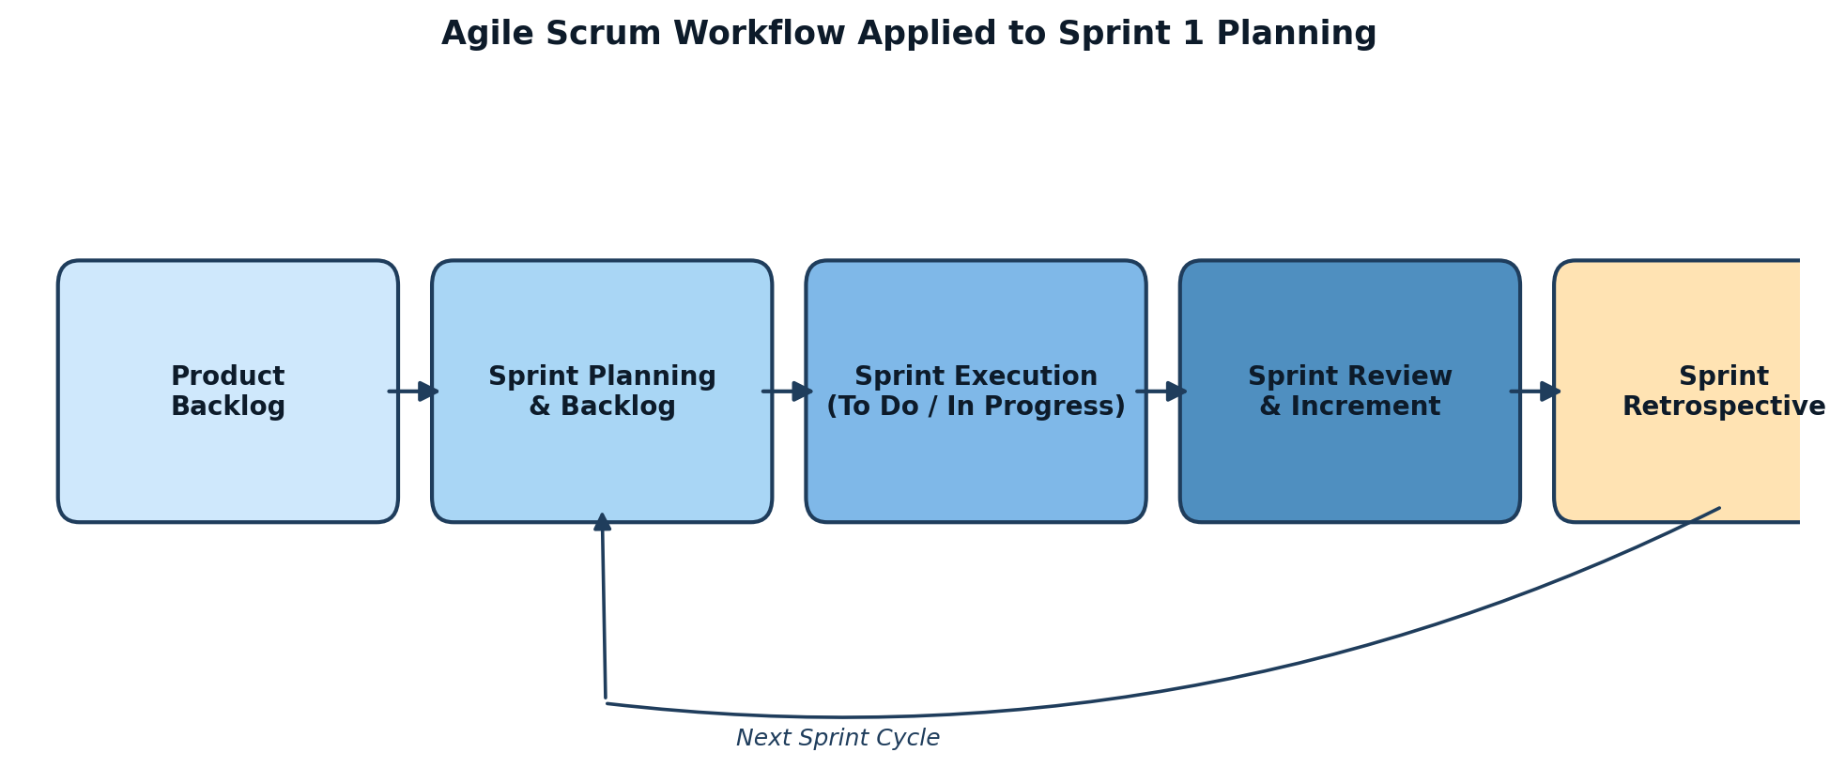
Figure 2: Scrum workflow applied to move Sprint 1 stories from Product Backlog through to a working Increment.

6. Effort Estimation Using Story Points
Story points were assigned using Planning Poker with the Fibonacci sequence (1, 2, 3, 5, 8, 13, 21), reflecting relative complexity, effort, and uncertainty rather than absolute hours. The development team discussed each story and converged on a consensus estimate.
Story | Title | Points | Justification
US-18 | Secure user registration & login | 3 | Standard, well-understood auth pattern (JWT, role routing); low technical risk.
US-01 | IoT sensor registration & configuration | 5 | Moderate complexity — device metadata handling, validation, and status tracking across an admin UI + API.
US-02 | Real-time sensor data ingestion | 8 | High complexity — requires a message broker, high-throughput time-series storage, and error handling for concurrent sensor streams.
US-04 | Real-time groundwater map dashboard | 8 | GIS integration, colour-coded live markers, and auto-refresh logic add significant frontend/data-sync complexity.
US-05 | Groundwater level trend visualization | 5 | Charting and aggregation logic are moderately complex but build on the data model already established by US-02.
US-19 | Critical threshold SMS/app alerts | 5 | Requires scheduler logic, third-party SMS gateway integration, and duplicate-suppression rules.
Total Sprint 1 Capacity Committed: 34 Story Points
This total was validated against the team's historical/assumed velocity of ~32–36 points per 2-week sprint for a 5-member cross-functional team (2 backend, 1 frontend, 1 IoT engineer, 1 QA), leaving a small buffer for unplanned work.
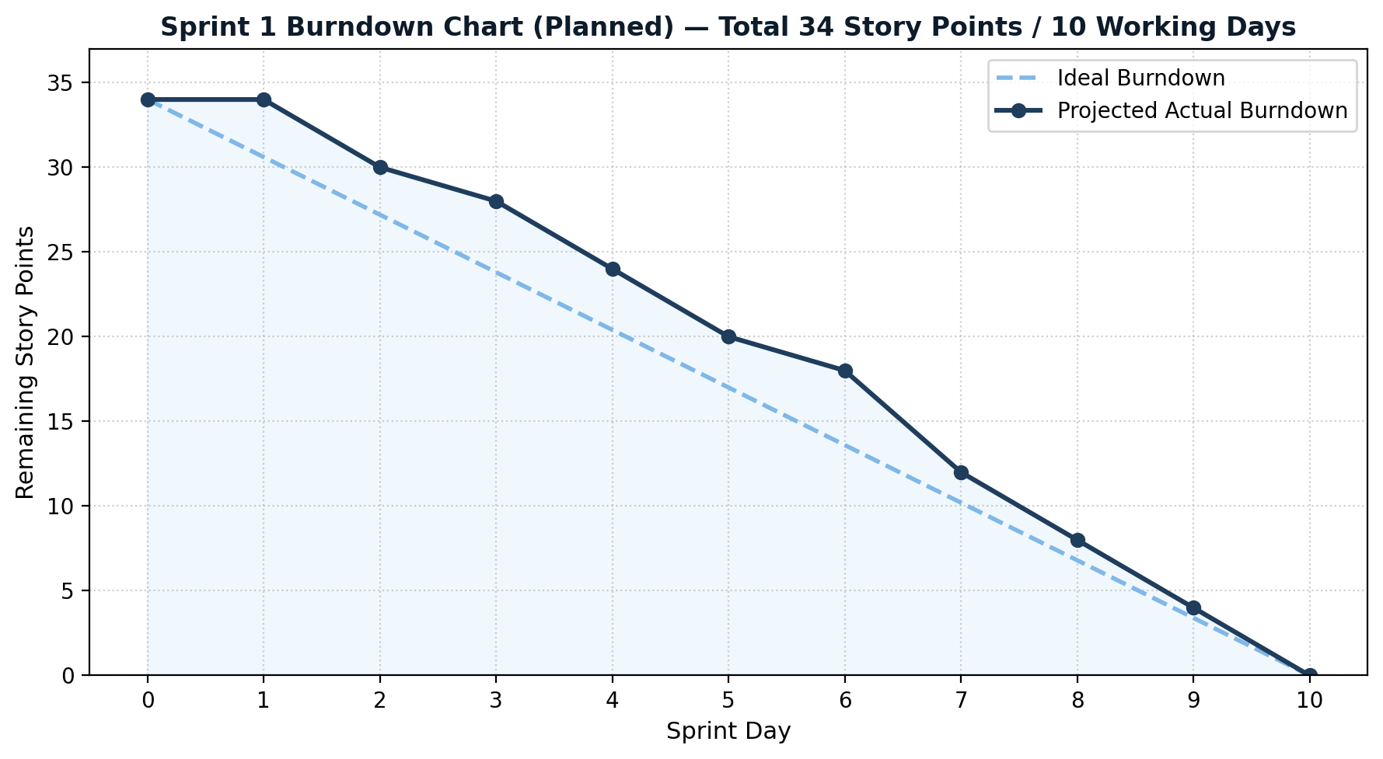
Figure 3: Planned Sprint 1 burndown showing ideal vs. projected completion of 34 story points over 10 working days.

7. Sprint Goal and Expected Deliverables

7.1 Sprint Goal
"Establish the foundational data infrastructure and core monitoring capability of the platform by enabling secure role-based access, onboarding IoT sensors, ingesting real-time groundwater/rainfall/soil-moisture data, visualizing current and historical groundwater levels on an interactive dashboard, and alerting stakeholders when levels cross critical thresholds."

7.2 Expected Sprint Deliverables
- A secure authentication module with role-based access for Farmers, Policymakers, and Administrators.
- A sensor registration and configuration module allowing field technicians to onboard IoT devices.
- A functioning real-time data-ingestion pipeline that reliably stores water-level, soil-moisture, and rainfall readings.
- An interactive web dashboard displaying a colour-coded groundwater map and historical trend charts.
- An automated threshold-based SMS/app alerting system for critical groundwater depletion events.
- A live sprint-review demo showing simulated sensor data flowing end-to-end into the dashboard, with an alert successfully triggered.

7.3 Definition of Done
- Code peer-reviewed, merged, and deployed to the staging environment.
- All acceptance criteria for each story verified through manual/automated testing.
- No critical or high-severity defects outstanding.
- Feature demonstrated to the Product Owner during Sprint Review.
- Documentation (API + user guide) updated for delivered features.

7.4 Next Sprint Preview
Sprint 2 will build on this foundation to deliver rainfall–recharge correlation (US-07), excessive-extraction detection (US-11), and the first version of the AI-based groundwater availability prediction model (US-09), once sufficient historical data has accumulated from Sprint 1's ingestion pipeline.

